Company name : Digital Magnet Media

Logo : Attached in mail   
Theme reference for website: [www.kensica.com](http://www.kensica.com) (But Swlpa Dark Theme Beku This is Actually Light)

This is the first Page Of the Website Same Barli Logo Home About Services Contact

## And Content Ready To Bring Your Brand to the Spotlight ? | Replacement : Helping You Lead, Digitally! Tag : Marketing Isn’t Digital, The World Is Button : Get Started || Replace : Get in Touch Image In First Page : Sliding images 3 Sec Of Digital Advertising Of anything. Add-ons : Full Page Whatsapp Button – Call Now Button (Need Both) Maybe Social Media Yella Icons Bandru Ok.

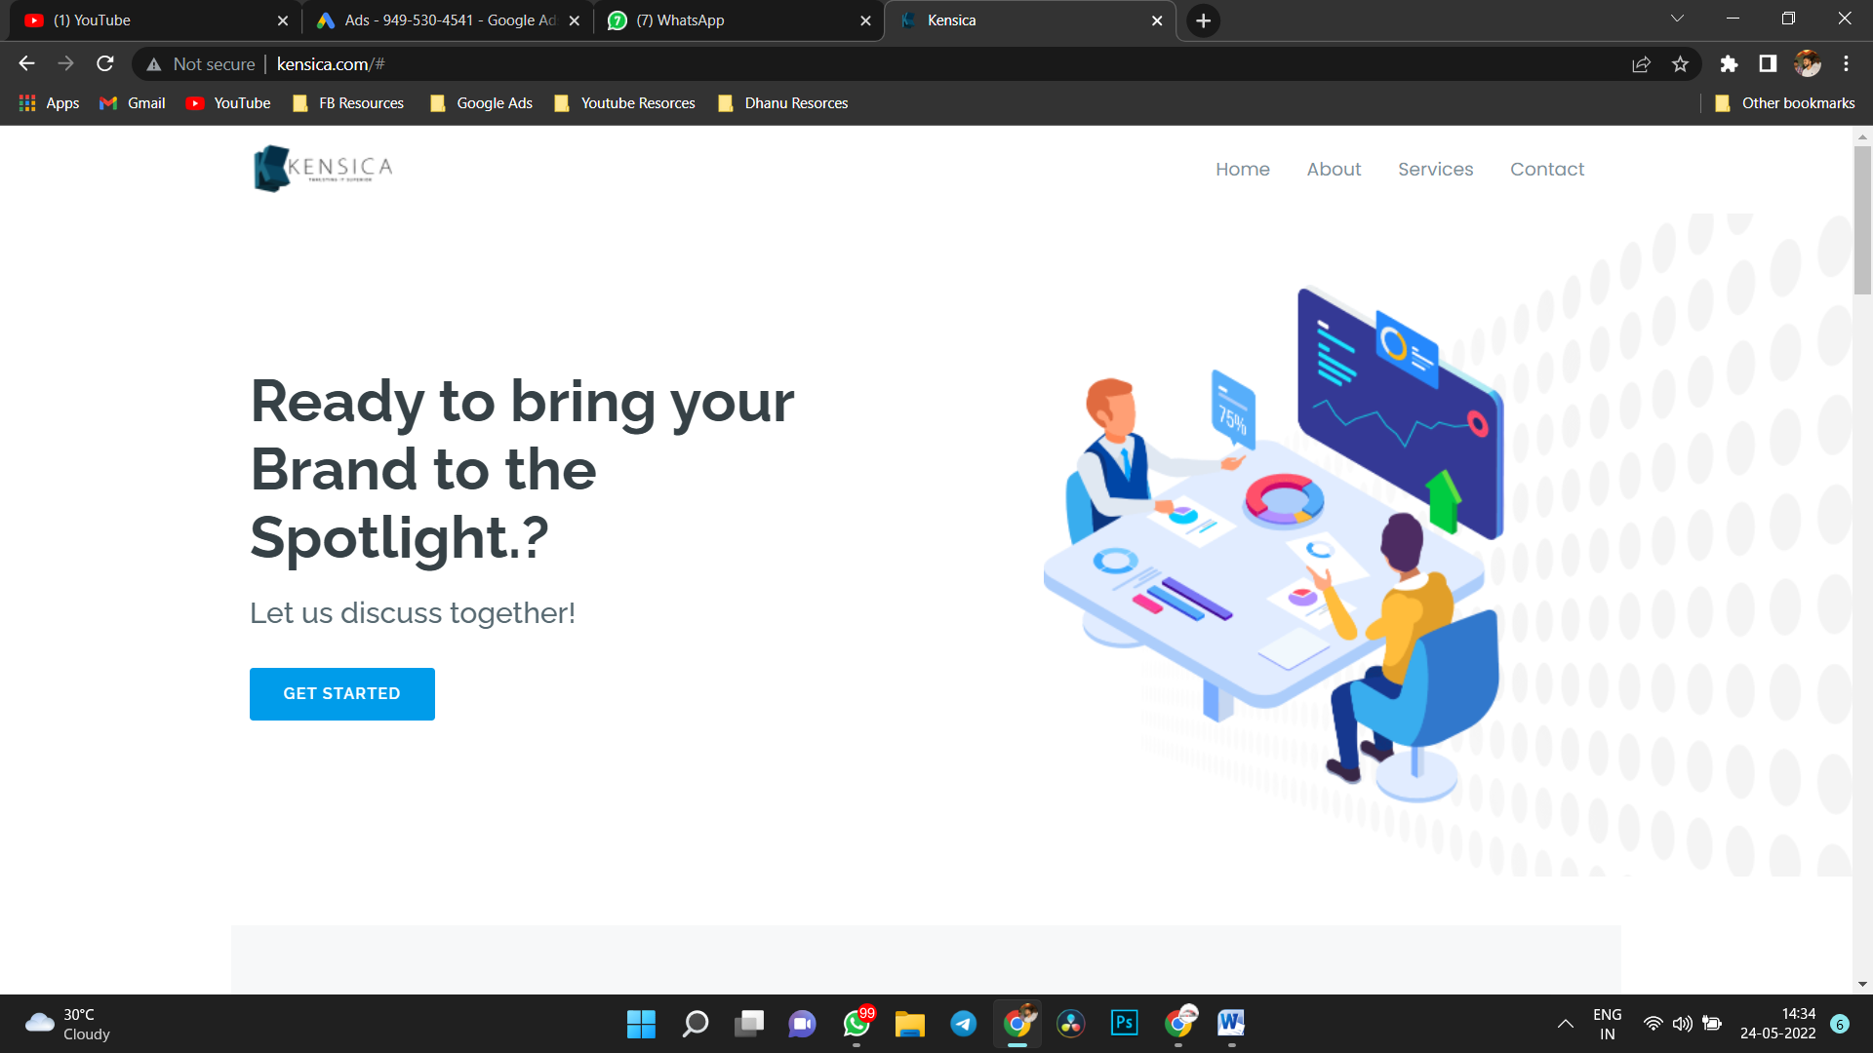

First Page Done ☺

Second Page   
  
About Us : WE ASSIST YOU IN IDENTIFYING, UNDERSTANDING, AND ATTRACTING THE RIGHT AUDIENCE.  
We are a top-tier Digital Marketing & Transformation firm that expertly marries the flavours of marketing and technology. We assist brands in using the power of digital to unlock growth potential through our unique solutions. We are honoured to be considered an extension of some of the most prestigious Companies. We simply collaborate with our clients as a team.  
  
  
Thrid Page   
Refrence : https://www.aandb.xyz/  
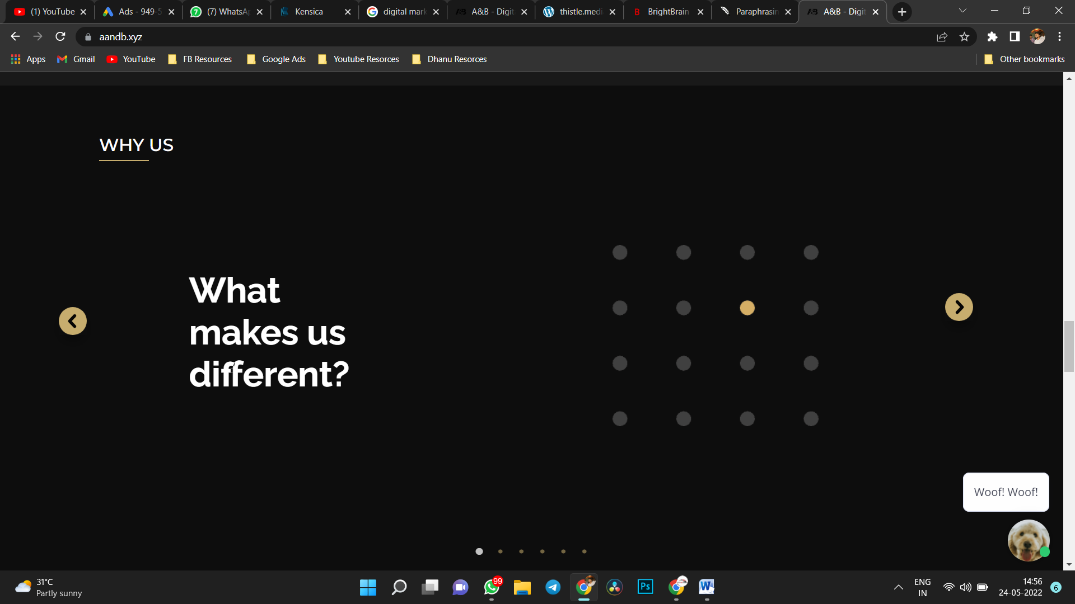

This Slide Same Content Copy madbidu Maga.

Fourth Page : **SERVICES**

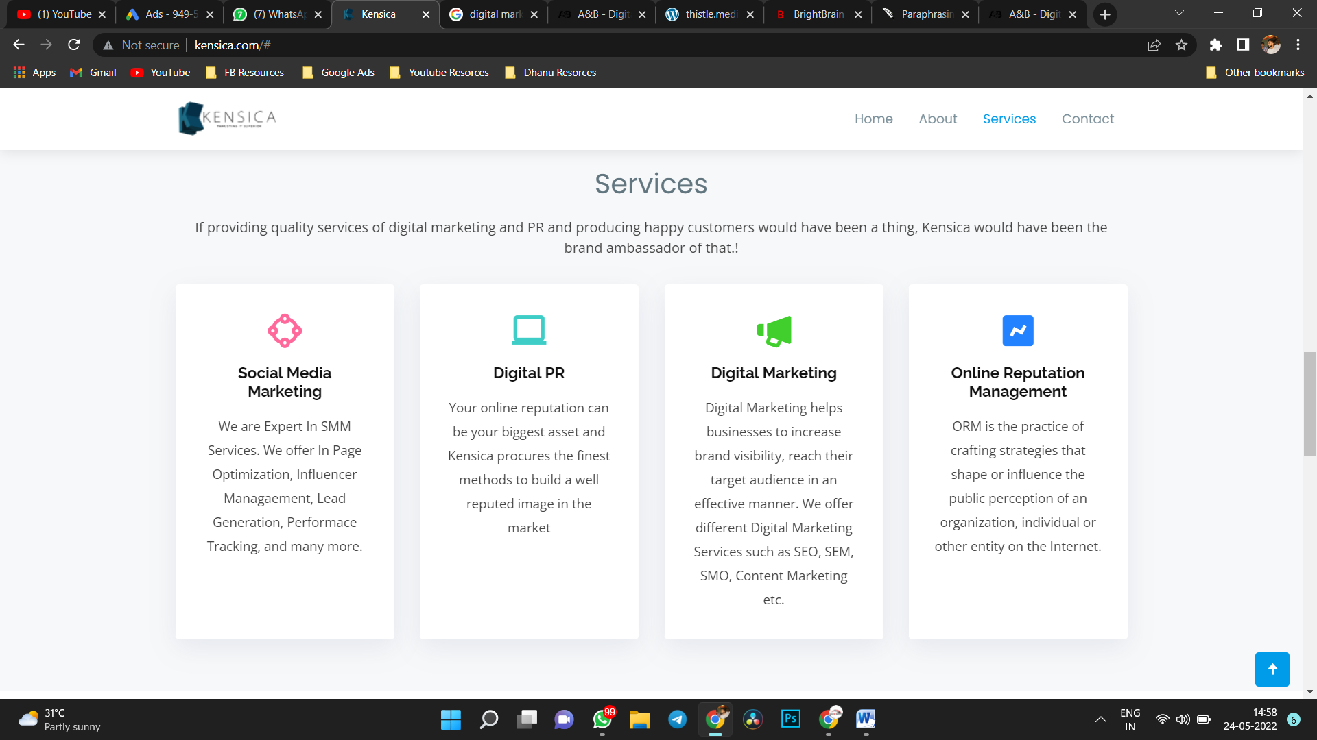

Social Media Marketing : We specialise in social media marketing services. In-page optimization, influencer management, lead generation, performance tracking, and more services are available.  
**Idralli See More button baruthe Adralli Bere Page alli Nandu Just Yt links Yella Update aguthe maybe idakke we would need admin panel Nandu full daily iruthe works adralli so.**  
  
Digital PR: Your Digital reputation might be your most valuable asset, and Kensica uses the most effective strategies to establish a well-known image in the market.

Digital Markting : Businesses may use digital marketing to raise brand awareness and effectively reach their target demographic. We provide a variety of digital marketing services, including SEO, SEM, SMO, and content marketing.  
  
Music Distribution : The link between your completed album and your prospective listeners Sell and stream your music on the world's most popular digital music shops and DSPs, including Apple Music, Amazon Music, YouTube Music, Wynk Music, Jio Saavn, and 150+ more. There are no annual or sign-up fees. We also provide playlists targeted at certain stores.  
  
Artist Management Tool : Our artist support team helps independent artists and labels get the resources they need. For forthcoming releases, our team also provides marketing strategy and advertising strategies.

Fifth Page: Clients   
  
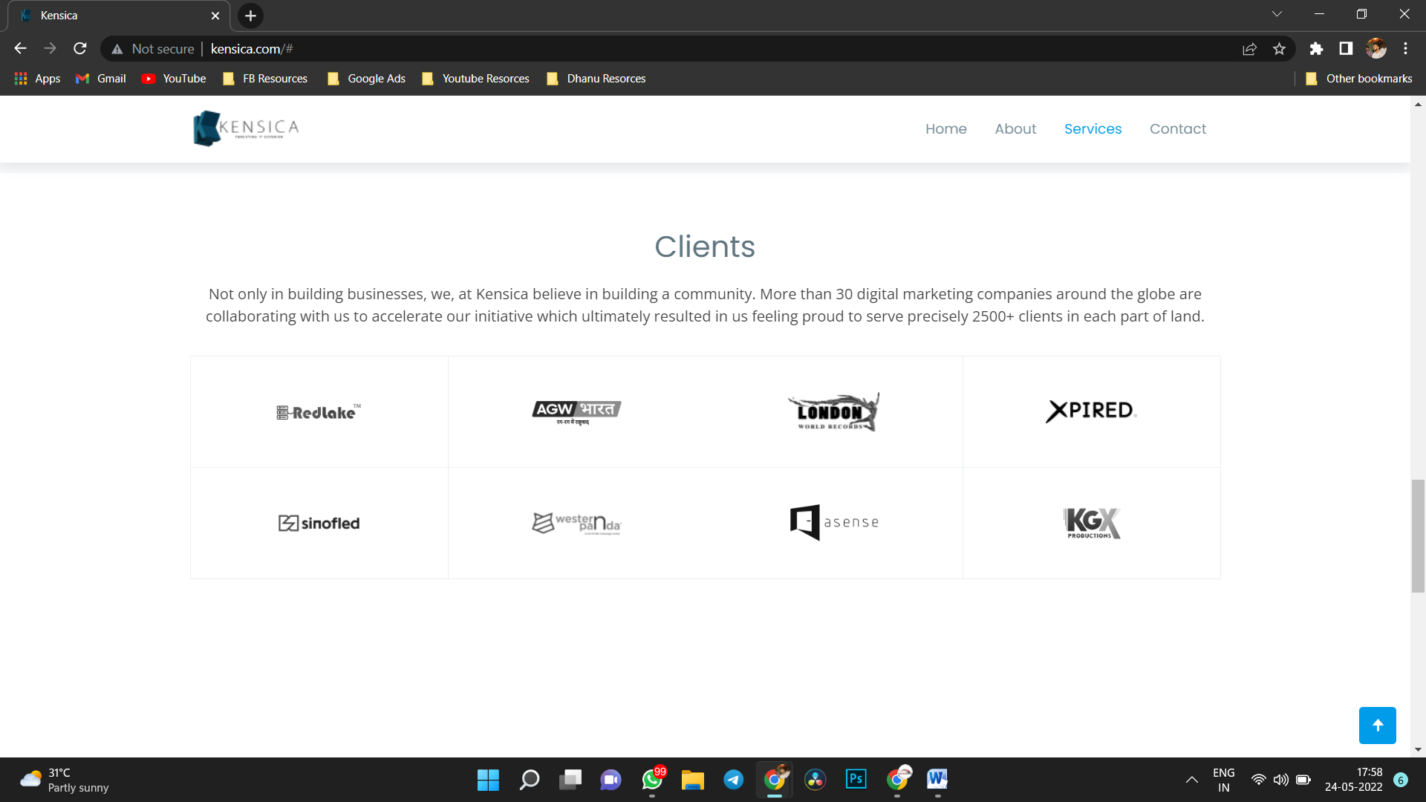

We at Digital Magnet Media believe in community building as well as company development. More than 30 digital marketing businesses around the country collaborated with us to help us speed our project, and we are now pleased to service over 2500 clients across Karnataka.

Clients Logo Will Be attached in the mail. And Logo Mele Cursor horde logo Revel Agbeku As given in the Ref.

Still Not Conform testimonials Bandre one page extra baruthe.

Page Six

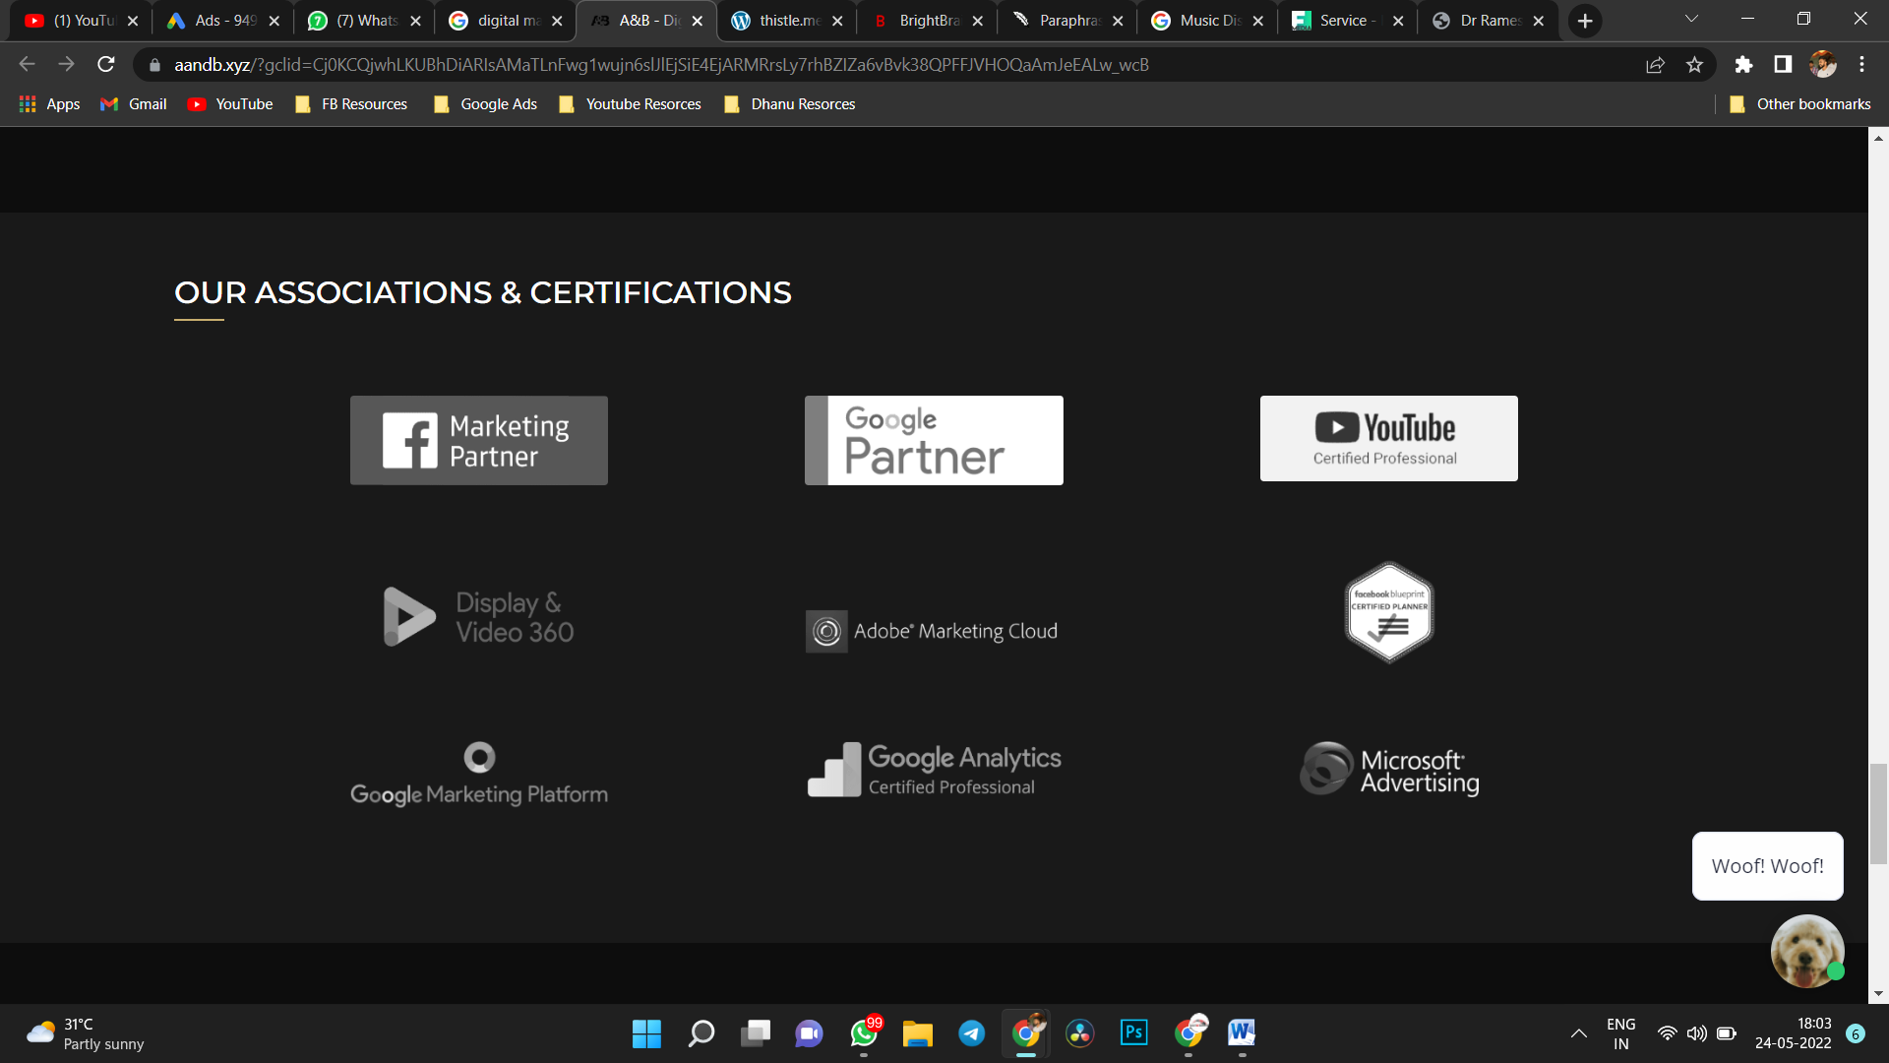

OUR ASSOCIATIONS & CERTIFICATIONS   
(nandu Idralli First 3 Kuda Idhe ) <https://www.aandb.xyz/>

Page Seven 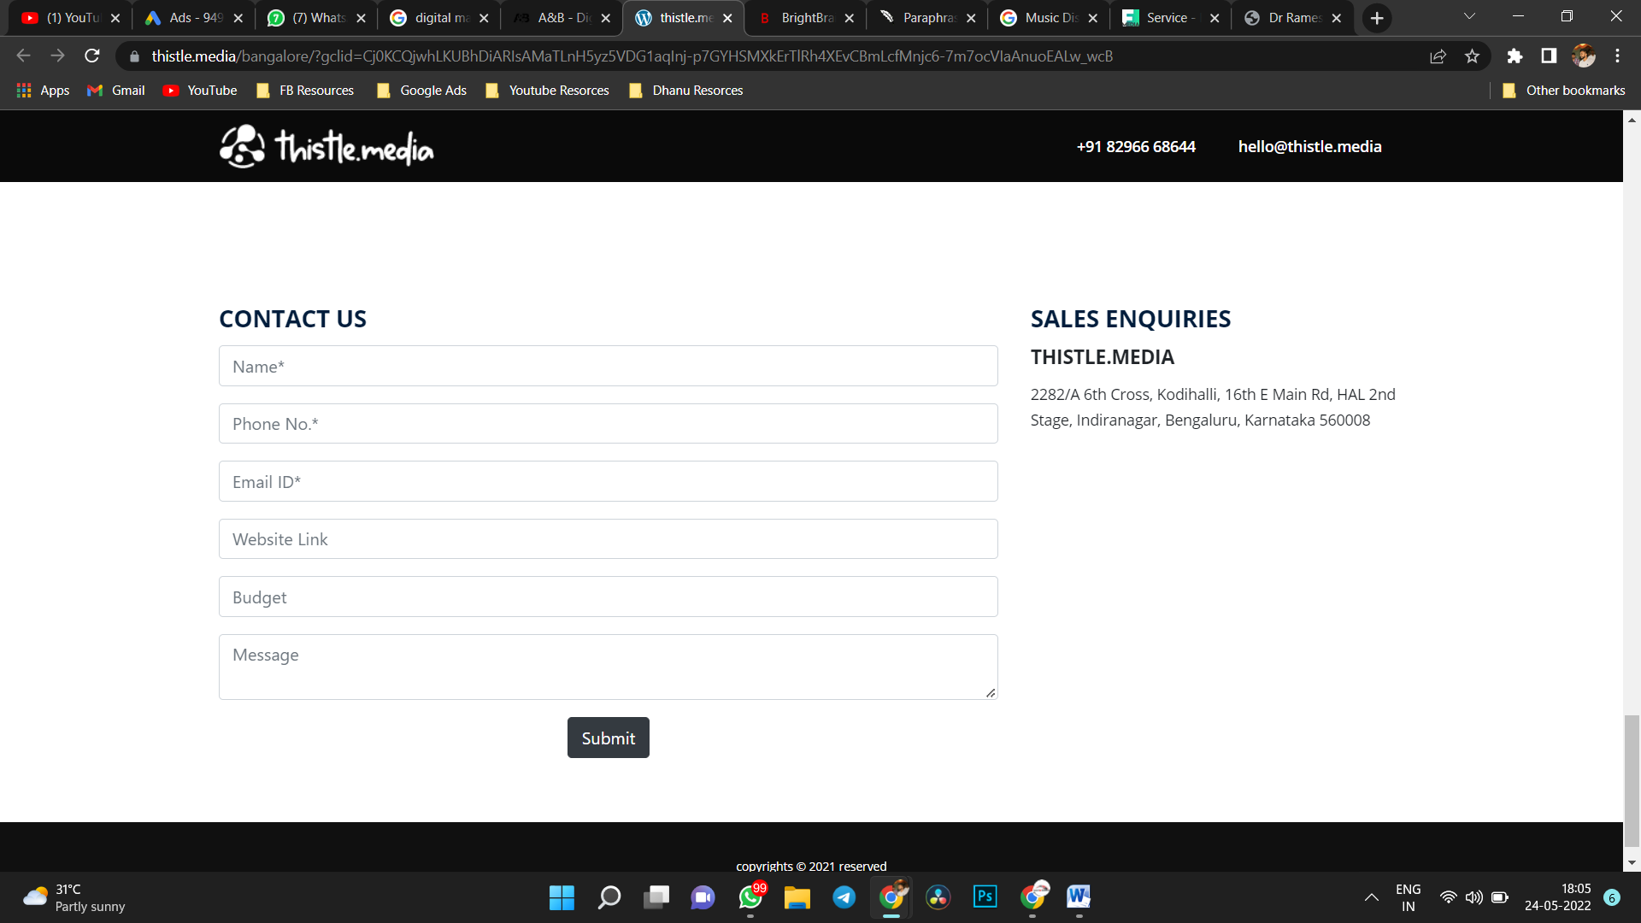

Contact Us   
Name :  
Phone No:  
Email ID :

Message:   
 **SUBMIT**

**Right alli same : Address, Digital Magnet Media ,Old Annaporneshwari Nagar Police station Building,** Papreddy Palya, 2nd Stage, Naagarabhaavi, Bengaluru, Karnataka 560072.  
Ph No: 7259455013

Links Os Social Medias   
Facebook : https://www.facebook.com/Digitalmagentmedia/  
Instagram : https://www.instagram.com/digitalmagnet.media/

**ASHTE NANDU WEBSITE ☺**